Strategy #2: Analyze Visual Evidence

Observe and analyze materials and visual evidence - artifacts, photographs, primary sources, posters (SS Skills Outcome).
The teacher prepares packages of posters or a Power Point Presentation using a series of vignettes, pictures, and/or posters. Each shows some aspect of the suffragist movement or the Persons Case. (See following for samples.)
The packages are distributed to the students in collaborative groups. They examine the visuals. If a Power Point presentation used rather than the packages, students view it.
In collaborative groups, students view, discuss and analyze the images and predict /suggest what each one tells about Nellie McClung, the suffragists and the Famous Five. If they have already read a story about McClung or seen a video, they may analyze the visuals and note what additional information they have gained.
In groups, students make posters illustrating/outlining what they have they have discovered in the visuals.
Each group shares their poster with the class.
The posters are kept and revisited after students have studied the life and accomplishments of Nellie McClung, the suffragists and the Famous Five.

Come out to hear

Nellie McClung

Author

from Manitou, Manitoba

Who will speak on her new book:

Sowing Seeds in Danny

Canadian Best Seller, this year!

At the Town Hall in Killarney

Thursday, September 18, 1908

at 8 O’clock sharp!

McClung is one the foremost
platform speakers in the west today.

Admission $.25

Compiled from material (dates, locations, topics) found on actual posters.

Do Not Fail to Hear

Mrs. Nellie L. McClung

Lecture on
Woman Suffrage,
Temperance and other
Political Issues

She is acknowledged Canada’s

greatest entertainer and orator.

Brandon Centre

July 7th, 1914, 8 P.M.

COME EARLY TO SECURE A SEAT -
YOU CAN’T AFFORD TO MISS HER!

Admission $.25

Compiled from material (dates, locations, topics) found on actual posters.

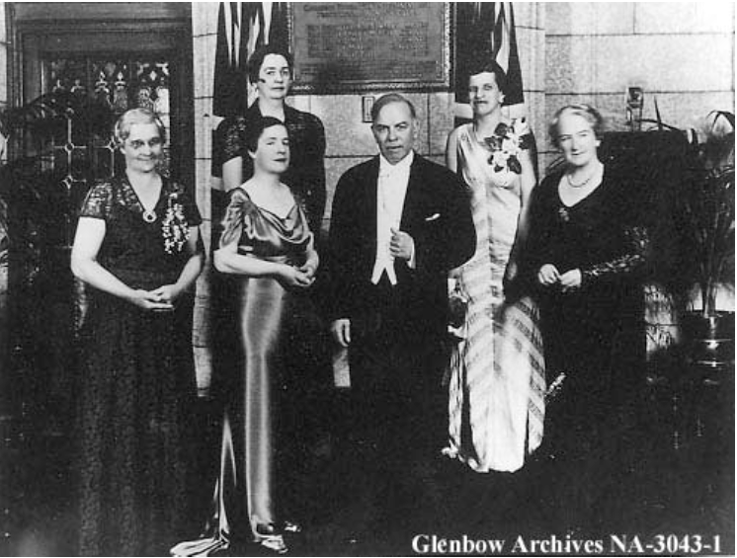
The unveiling of a plaque in the lobby of the Senate commemorating the Persons Case, June 11, 1938. Used with permission from the Glenbow Museum.

Front row, L-R: Mrs. Muir Edwards, daughter-in-law of Henrietta Muir Edwards; Mrs. J.C. Kenwood, daughter of Judge Emily Murphy; Rt. Hon. Mackenzie King; Mrs. Nellie McClung.

Rear row, L-R: Senators Iva Campbell Fallis and Cairine Wilson

Nellie McClung was only member of the Famous Five who attended the ceremony held for the unveiling of a plaque commemorating Persons Case, which established that women were “persons” under the BNA Act.
Three of the members of the Famous Five had died and one other, Irene Parlby had stayed home in Alberta. Nellie Stood next to the Prime Minister and spoke after him. She spoke for the group. “She talked about the long campaign to convince the world women had souls and that they had minds and then that they deserved the right to political office.”

Nellie McClung, Charlotte Gray p.15

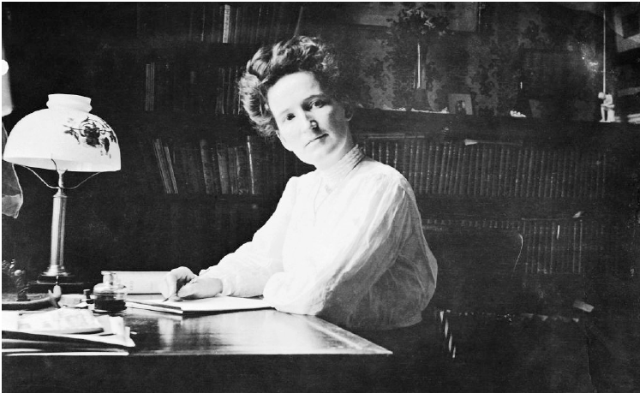
Nellie McClung. Used with permission from the Glenbow Museum.

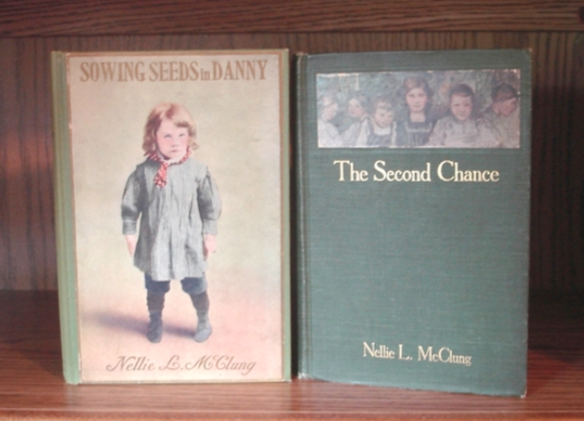
Published in 1908, Sowing Seeds in Danny was a Canadian Best Selling Book. The Second Chance, published in 1910, was also a popular book in Canada.

The Manitoba Press
January 28, 1916

Manitoba Women
the First to Win the Vote!

Last night at the Manitoba Legislature, a Bill to enfranchise women in Manitoba passed its third reading. The galleries were crowded and the air was filled with excitement as the vote was taken.

The long campaign involving suffragists such as Nellie
McClung, Francis Beynon, her sister Lillian Beynon and
Cora Hind, led to this historic event.

Compiled from articles written about the vote.

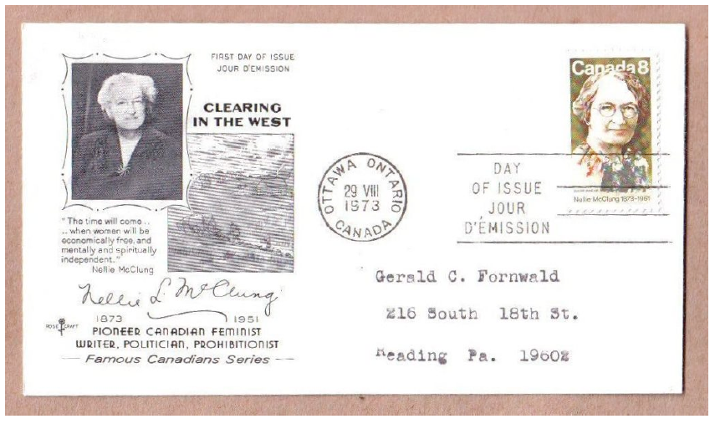
A First Day Cover is an envelope with a new stamp and cancellation showing the date the stamp was issued.
The postmark or cancellation applied to that stamp is dated on the date and at the location that the postage stamp is first placed on sale. Most collectors also want a printed design on the envelope that explains or provides additional information about the stamp. This printed design is called a cachet.

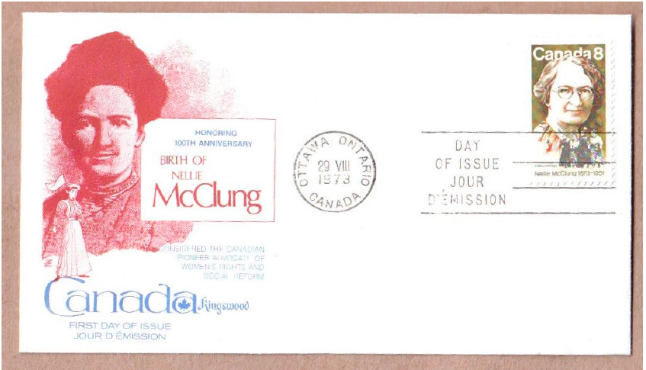
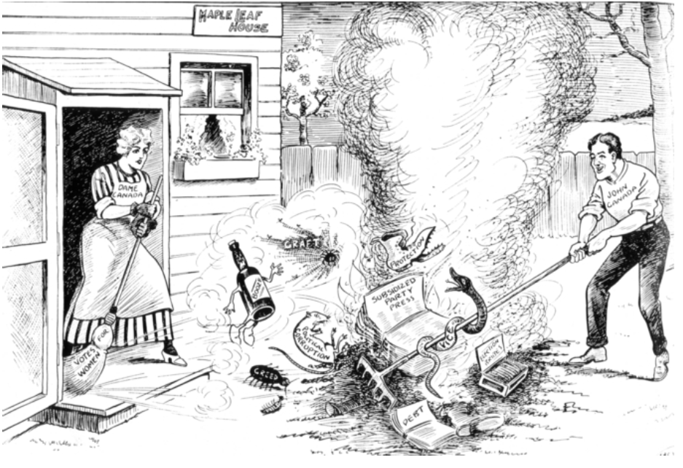
“Canada needs a Clean Up Week,” showing Dame Canada sweeping with a broom labelled “Votes for Women.”

Source: Archives of Manitoba/Archives du Manitoba, Arch Dale 22, N8929 Year: 1915

The Manitoba Press
January 28, 1916

Manitoba Women
the First to Win the Vote!

Last night at the Manitoba Legislature, a Bill to enfranchise women in Manitoba passed its third reading. The galleries were crowded and the air was filled with excitement as the vote was taken.

The long campaign involving suffragists such as Nellie
McClung, Francis Beynon, her sister Lillian Beynon and
Cora Hind, led to this historic event.

Compiled from articles written about the vote.

A First Day Cover is an envelope with a new stamp and cancellation showing the date the stamp was issued.
The postmark or cancellation applied to that stamp is dated on the date and at the location that the postage stamp is first placed on sale. Most collectors also want a printed design on the envelope that explains or provides additional information about the stamp. This printed design is called a cachet.

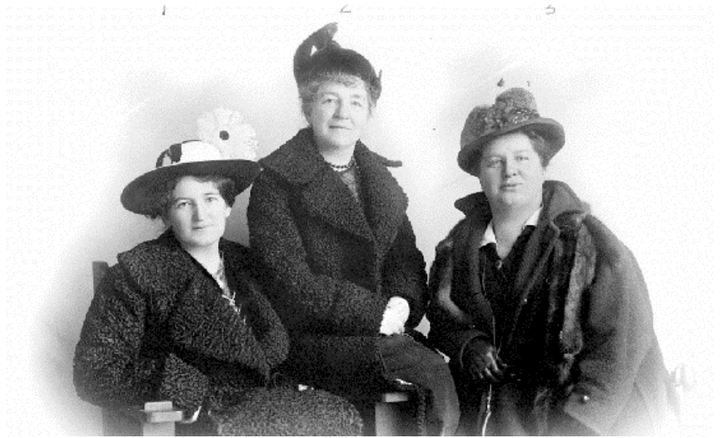
L to R: 1) Nellie McClung with 2) Alice Jamieson and 3) Emily Murphy in 1916.
Used with permission of the BC Archives B-06791.

1) Nellie McClung and her family moved from Manitoba to Alberta in 1914. She returned to Manitoba in 1915 to campaign for T.C. Norris and the Liberal party who promised to enfranchise women if elected. Norris and the Liberals won the election, and on January, 28, 1916, Manitoba women became the first in Canada to win the right to vote in provincial elections and to hold provincial office.

“Suffrage societies across the country celebrated this first victory. Others followed quickly. Alberta’s turn came in April. (1916) On the day that women got the vote in that province, Alice Jamieson (Canada’s first woman appointed to a court) linked arms with a jubilant Emily Murphy and Nellie McClung as they walked down Jasper Avenue seeking some way to celebrate the occasion . As they could not drop into a bar for a drink, they bought new hats and had their photo taken.”
- Hallett and Davis, Firing the Heather, p. 150.

2) Alice Jamieson (Herstory 1990) was appointed judge of the juvenile court in Calgary in 1914. She became the first woman in Canada and in the British Empire, appointed to a court. In 1916, a short time after Emily Murphy's appointment in Edmonton, she also was appointed magistrate of the women's court.

3) Emily G. Murphy (1868-1933), the women who started the Persons Case, writer, and first woman magistrate in the British Empire. She pioneered married women's rights, was National President of the Canadian Women's Press Club 1913-1920, vice-president of the National Council of Women and first president of the Federated Women's Institutes of Canada.

The Canadian Times
October 18, 1929

Read All About It!

Privy Council Decision Has Been Made:
Canadian Women Are Declared Persons

Thanks to the Famous Five, Emily Murphy, Nellie
McClung, Louise McKinney, Henrietta Muir Edwards, and Irene Parlby, women in Canada are now legally defined as “persons.”

Compiled from information found in newspapers at the time.

