Nellie McClung
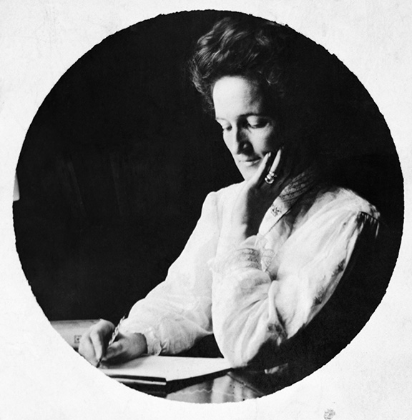
Photo used with permission from The Glenbow Museum

Vote To Make A Decision
One day, a teacher told her Grade 4 class that they could have a Field Trip.
She said that they had two choices.
They could visit the Zoo or they could visit the Museum.
She wrote both ideas on a ballot.

VOTE

Check the Field Trip you want.
1. Go to the Zoo ______

2. Go to the Museum ______

She handed the ballot out to all the boys in the class. They checked the one they wanted. They handed the ballots back to the teacher. She counted the ballots.
Nine boys voted for the zoo. Five boys voted for the museum.
The teacher announced that the class would go to the zoo.
What do you think about the way the Field Trip was planned?

People and Terms
Ballot | The paper on which people mark who or what they are voting for.
Government | The Government is the organization that runs a country, province, town or city.
One room school | A school in which many grades (1-8) are all taught together in one room.
Wawanesa | The town near the location of Nellie McClung’s family farm
Campaign | A race between candidates for elective office
E. Cora Hind | A woman in Manitoba who fought for the vote and other rights for women
Lillian Beynon Thomas | A woman in Manitoba who fought for the vote and other rights for women
Frances Beynon | A woman in Manitoba who fought for the vote and other rights for women
Premier | The leader of the government in a Province in Canada
Premier Roblin | A Premier of Manitoba (October 29, 1900 – May 12, 1915)
Walker Theatre | A theatre in Winnipeg
Legislature | A place where laws are made
Member of the Legislature | A person who is elected to the Legislature.
Officially (officially persons) | Women became officially persons in 1929, that is women were, in fact, persons under Canadian Law.
“The Famous Five” | Emily Murphy, Nellie McClung, Irene Parlby  Louise McKinney, Henrietta Muir Edwards  They fought to have women known as Person’s under Canadian Law
Monument and statues | A structure put up to remember persons or events
Political Equality League (PEL) | A group of people in Manitoba who fought for women get the vote. Some members: Nellie McClung, Cora Hind, Dr. Mary Crawford, Lillian Beynon Thomas, Frances Beynon, Mrs. F. Dixon (and more)

Nellie McClung –

She Helped Build Manitoba
By Bette Mueller

One hundred years ago, women in Canada could not vote for the government of Canada or the government of any Province. Many people thought this was good. Some people such as Nellie McClung believed it was wrong. She thought women should be able to vote.
Who was Nellie McClung?
Nellie Moonie grew up on a farm in Ontario. She moved with her family to Manitoba where they started a farm near Wawanesa.
She was seven years old. Nellie started school when she was 10 years old. She liked to go to school and wanted to be a teacher. By the time she was 16 years old, she was a teacher.
The first school she taught in was a little one-room country school seen here. It was named Hazel School.
Some of her students were almost as old as she was.
She lived with a family on their farm.
Next, she moved to Manitou and began teaching at a larger school in the town.
There, she met other women who had ideas about how the world might be improved. One of the women was Mrs. Annie McClung. Mrs. McClung believed that women and children would have better lives if women could vote. Nellie also met Mrs. McClung’s son, Wesley. He owned a Drug Store in Manitou.
Nellie and Wesley McClung were married in 1896. She quit teaching. During the next nine years, they had four children. They bought this house in Manitou.
Photo with permission from Manitoba Archives
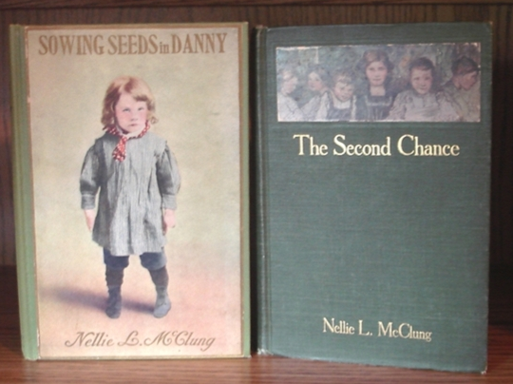
They lived in it until when they moved to Winnipeg in 1911.
Nellie had always loved to read and she wanted to become a writer. While they lived in this house, Nellie began writing. She wrote a book, “Sowing Seeds in Danny.” It was the most popular book in Canada that year.
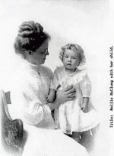
People began to ask her to make speeches about her book. She wrote another book and was asked to speak about her writing in other towns and in other provinces.
At the same time, Nellie became more and more interested in the rights she thought women should have. She met with women in Winnipeg who had the same ideas.
In 1911, Nellie and Wesley McClung with their four children moved to Winnipeg. In Winnipeg, Nellie joined with other women such as E. Cora Hind, Lillian Beynon Thomas and Frances Beynon as well as some men who wanted women to have the vote. They formed a group, The Political Equality League, that would fight for it.
Photo from British Columbia Archives
During the next few years, the women made speeches and met with people to talk about how to get more rights for women.
One person they met with was the Premier of the Province of Manitoba, Premier Roblin. Nellie, along with other women, asked Premier Roblin to give women more rights. Premier Roblin told them that he was very much against giving the vote to women. He said women should not have the vote. They should stay home. He told them, “Nice women do not want the vote.”
Photo – made from a painting by Manitoba Artist, Marilyn Young
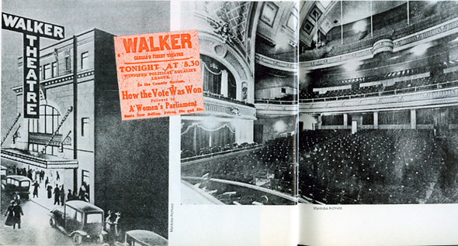
The next day, the women held a play at the Walker Theatre in Winnipeg. The play made fun of the Premier. The women pretended that men did not have rights. The men had to ask the Premier for the vote. Nellie McClung took the part of the Premier. She explained why men should not have the vote.
Photo of Manitoba’s Walker Theatre
She added, “Perhaps the time may come when men may vote with the women.”
The play was very successful.
Nellie McClung and the rest of the group kept campaigning. They rode by train to towns throughout Manitoba to speak to groups of people. Finally, in January 1916, the women in Manitoba gained the vote.
Women in Manitoba were the first in Canada to have the right to vote in a Provincial Election.
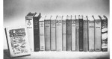
Before the women in Manitoba received the vote, Nellie McClung and her family moved to Alberta. She fought for the vote for women there. Nellie ran in an election in Alberta and became a member of the Alberta Legislature.
She also continued to write. She wrote 16 books in all.
"Souvenir Photo collection -
M.J.G. McMullen
Later, in Alberta, Nellie and four other women, fought for another right. That was the right for women to be known, “officially”, as persons in Canada. The group won that right in 1929. They became known as, “The Famous Five.” Besides Nellie McClung, “The Famous Five” refers to Emily Murphy, Irene Parlby, Louise McKinney, and Henrietta Muir Edwards.
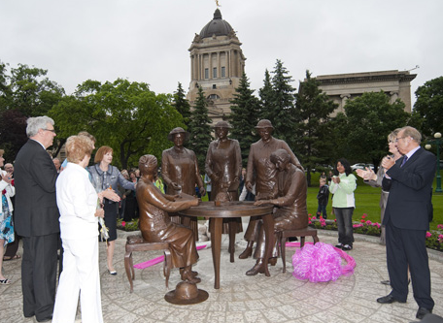
Nellie and Wes retired in Victoria. She continued to speak and write about rights for people.
Many monuments may be seen in Canada that recognize the life of and achievements of Nellie McClung.
This picture shows the unveiling of the Famous Five monument in Winnipeg in 2010.
Photo from Nellie McClung Foundation
In 1973, one hundred years after she was born, Nellie McClung’s picture was on the Canadian stamp.
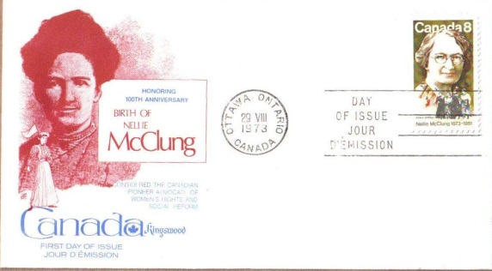
People remember Nellie McClung as someone who helped women gain the vote. She was a wonderful speaker, an educator and a well-known author. She spent her life helping others gain rights.
Stamp from Nellie McClung Foundation Collection

